**Script postman**

**Account**

GET: <http://localhost:8080/rest/accounts>

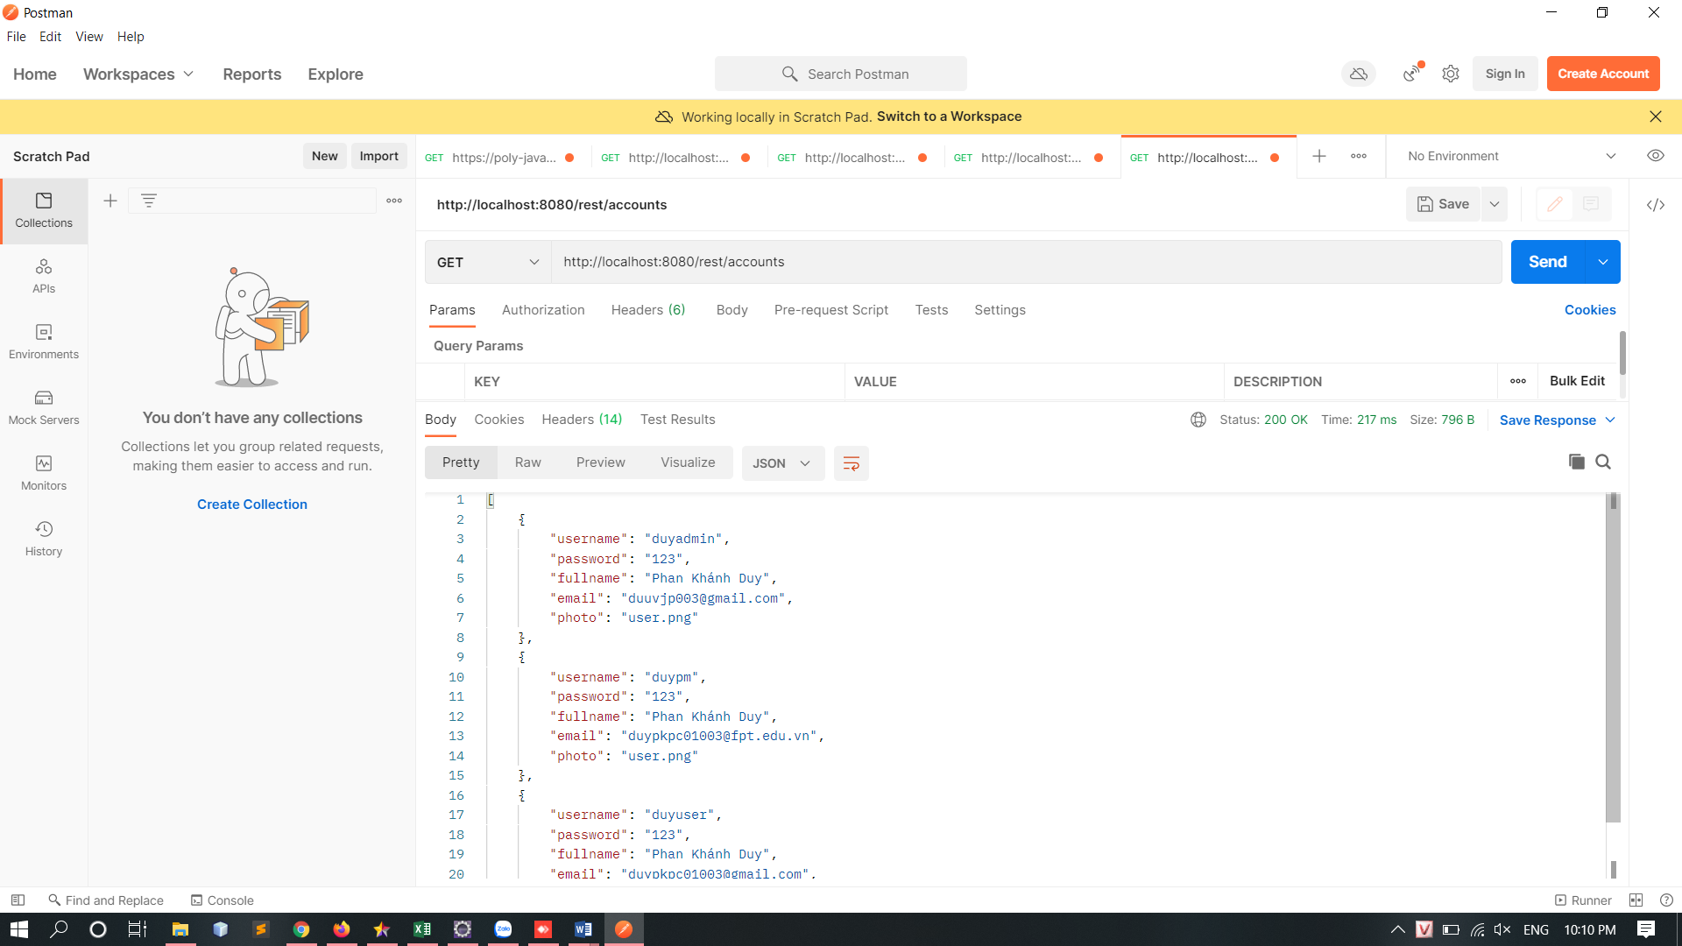

POST: <http://localhost:8080/rest/accounts>

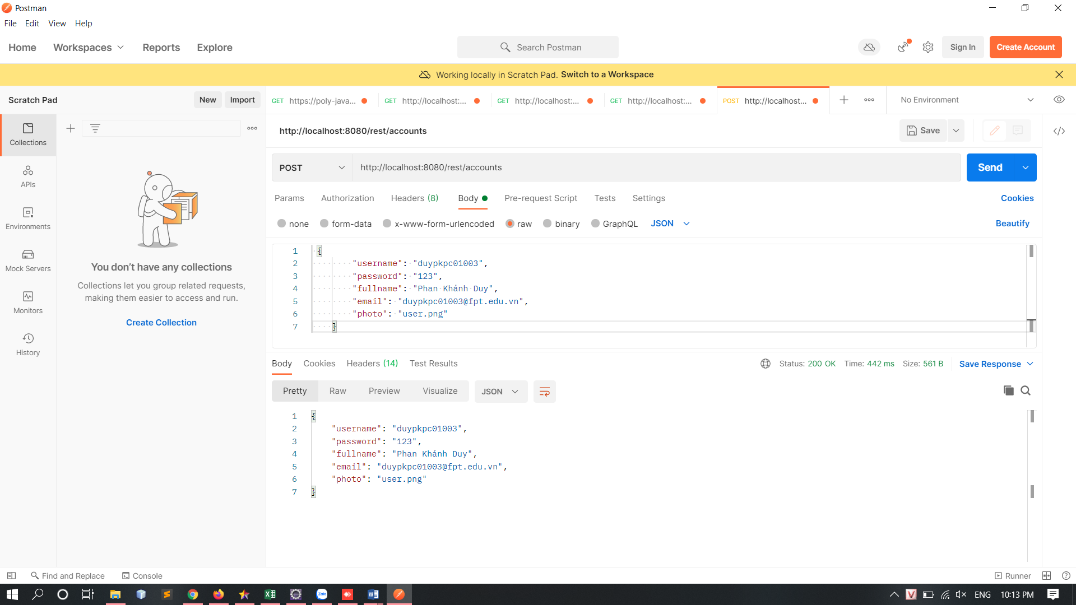

PUT: <http://localhost:8080/rest/accounts/duypkpc01003>

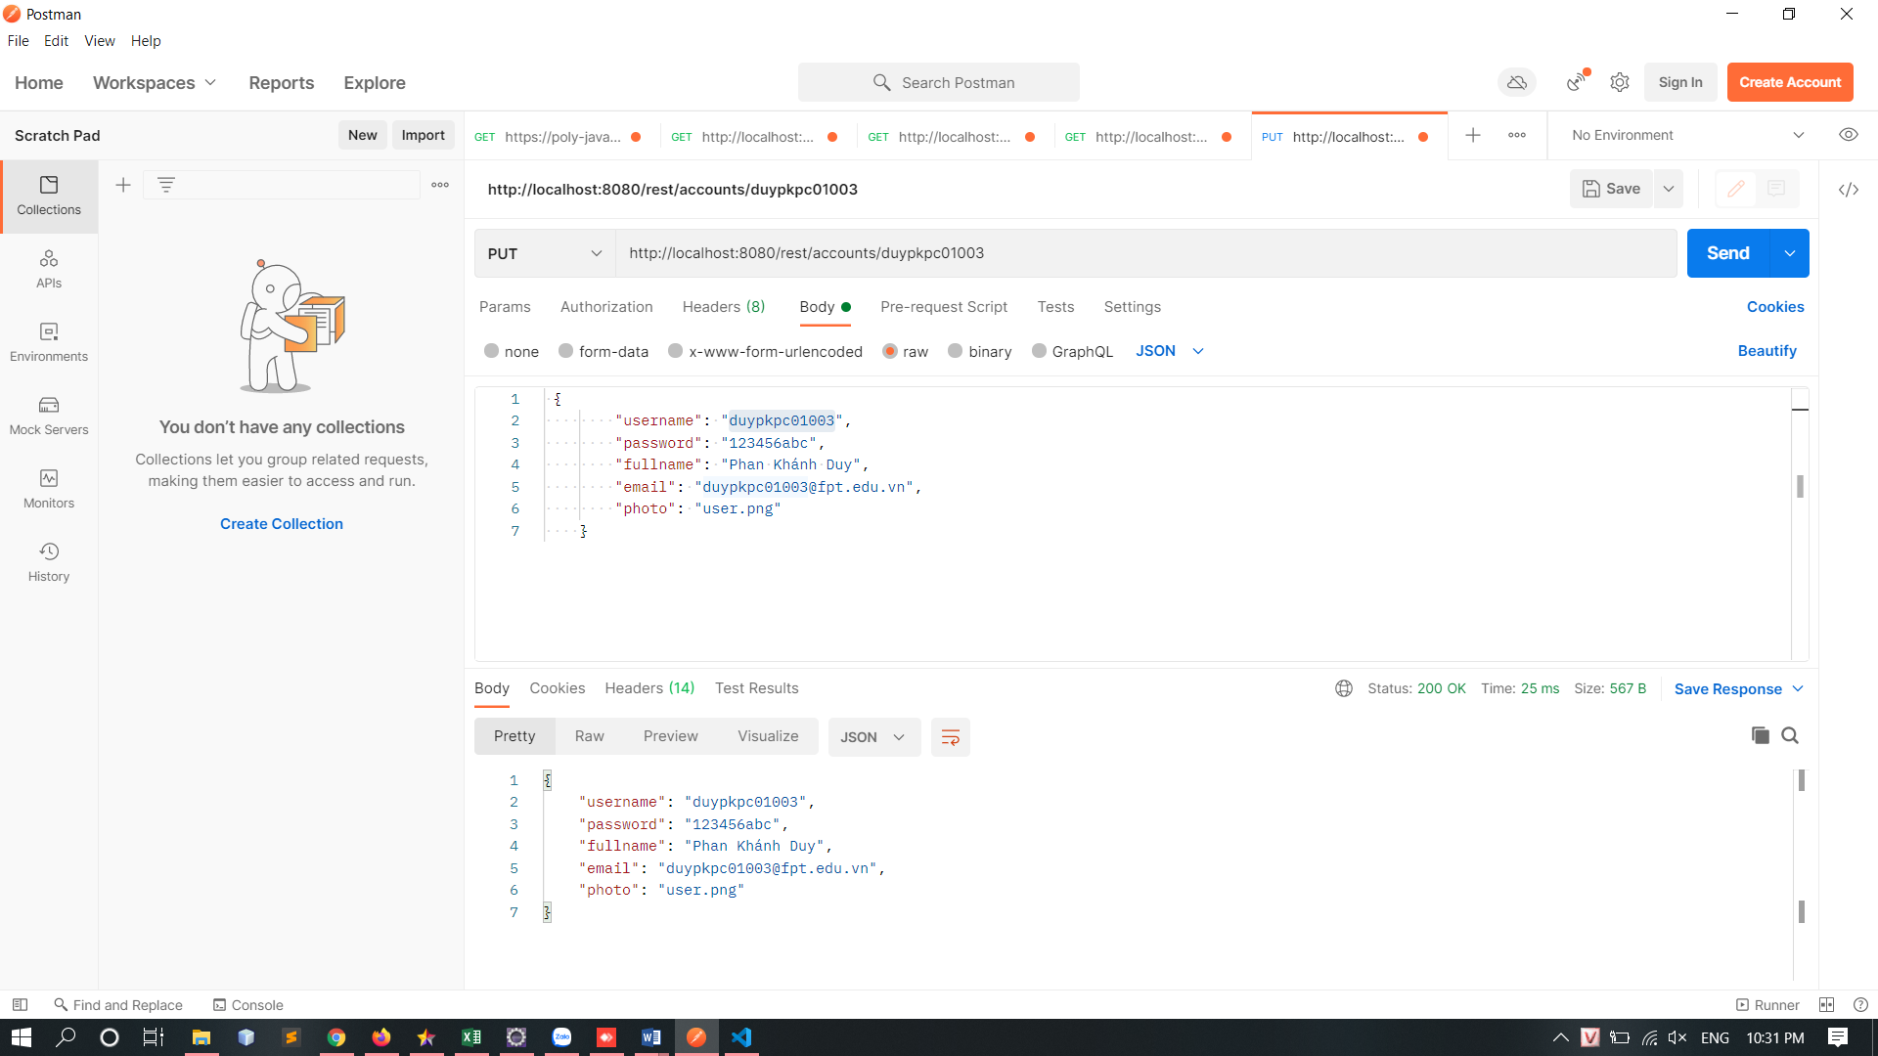

DELETE: <http://localhost:8080/rest/accounts/duypkpc01003>

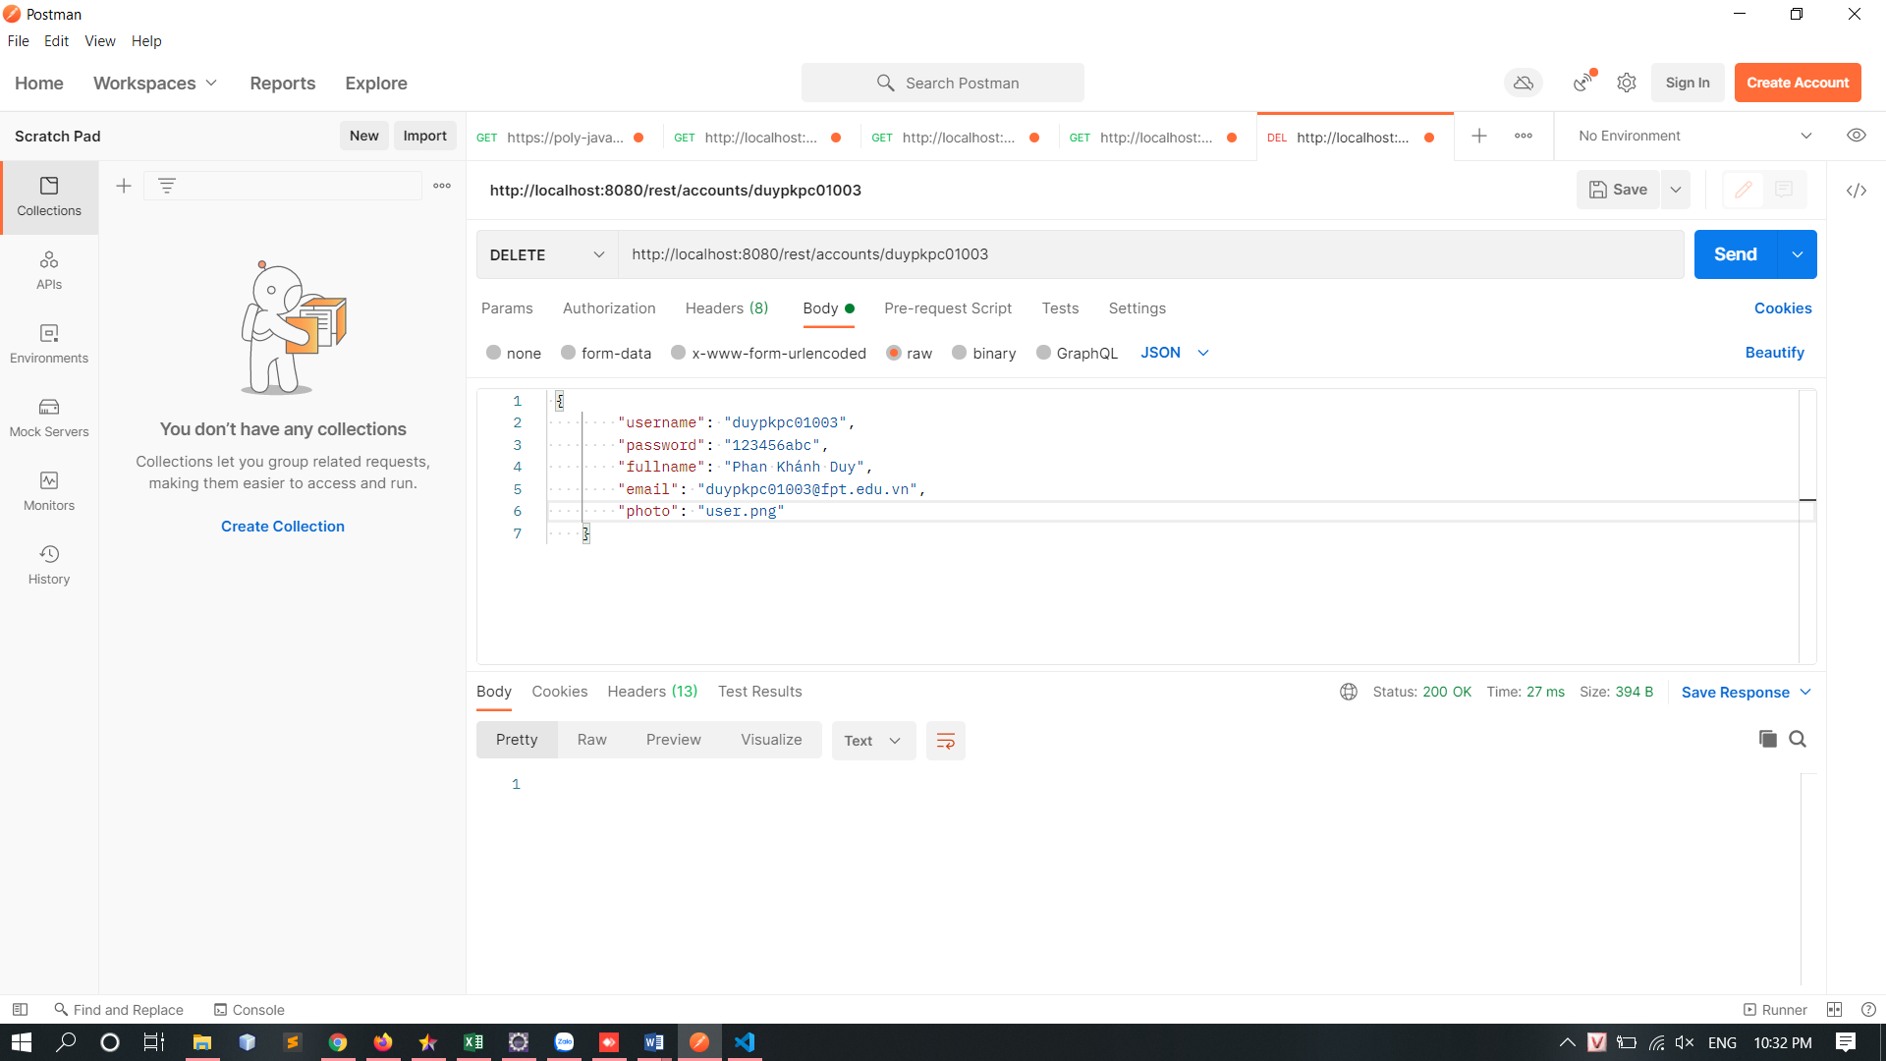

Products

GET: <http://localhost:8080/rest/products>

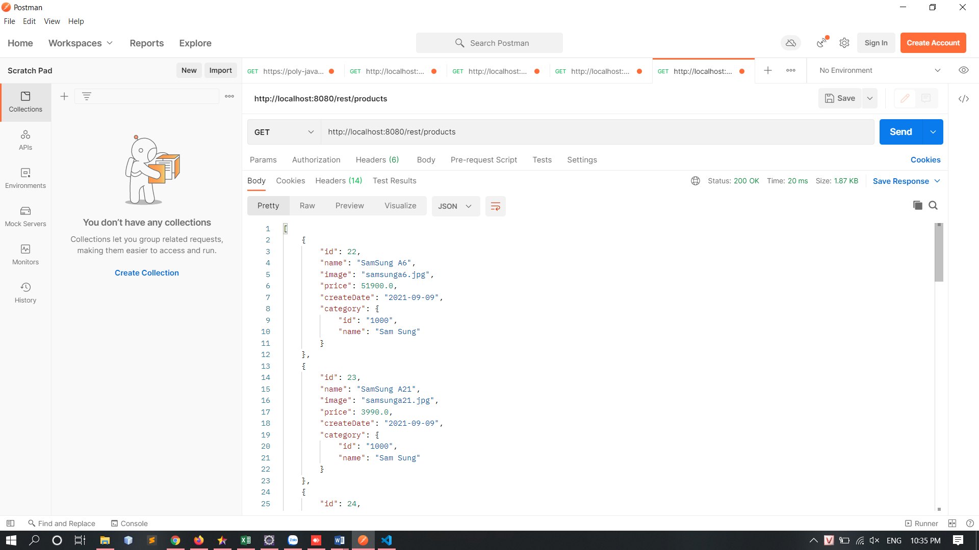

POST: <http://localhost:8080/rest/products>

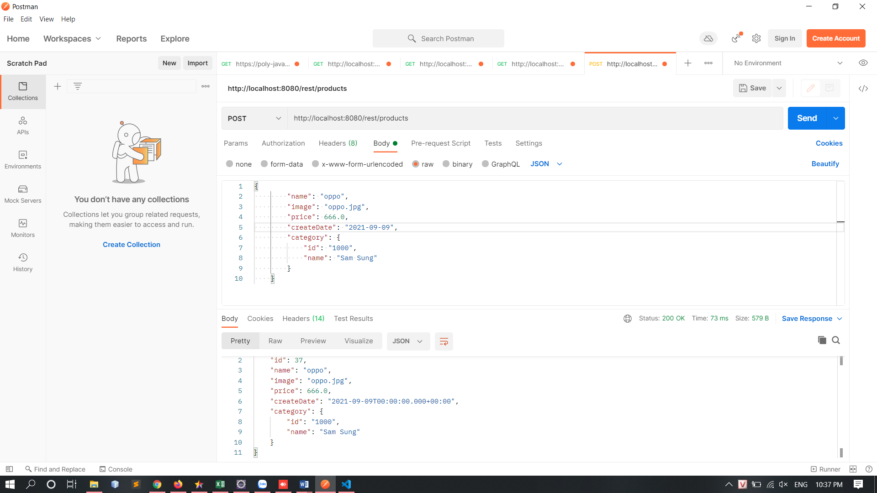

PUT: <http://localhost:8080/rest/products/37>

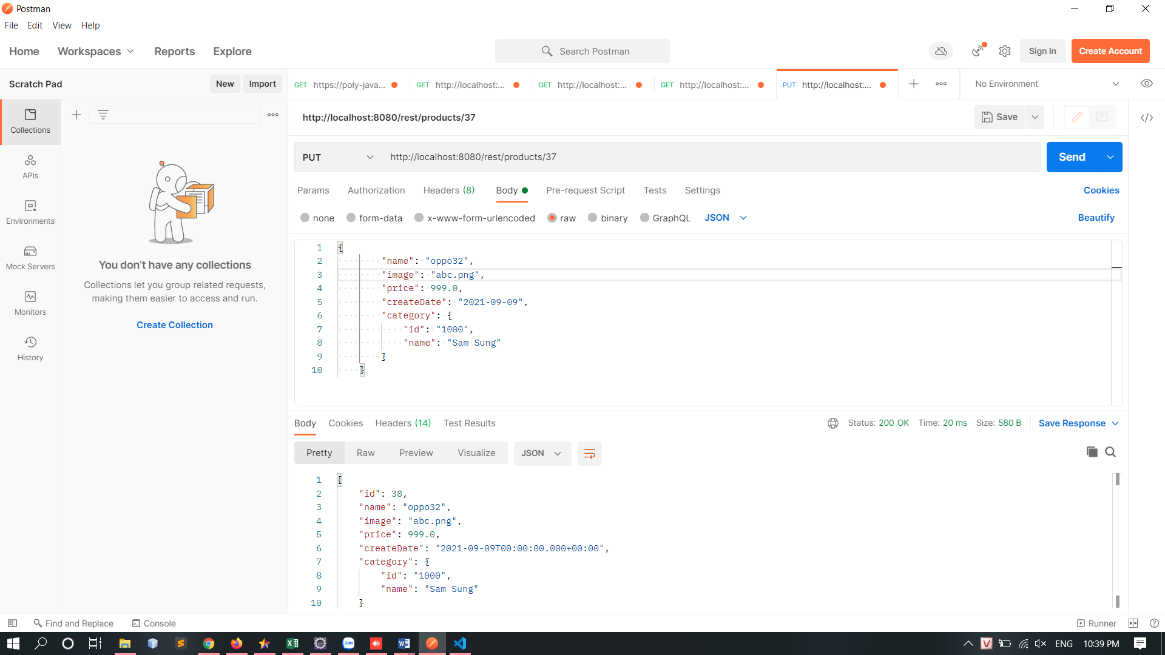

DELETE: <http://localhost:8080/rest/products/37>

